The following repositories are not connected:

-https://jazz.net/downloads/clm/5.0.2/5.0.2/install-repository/clm-offerings/repository/repository.config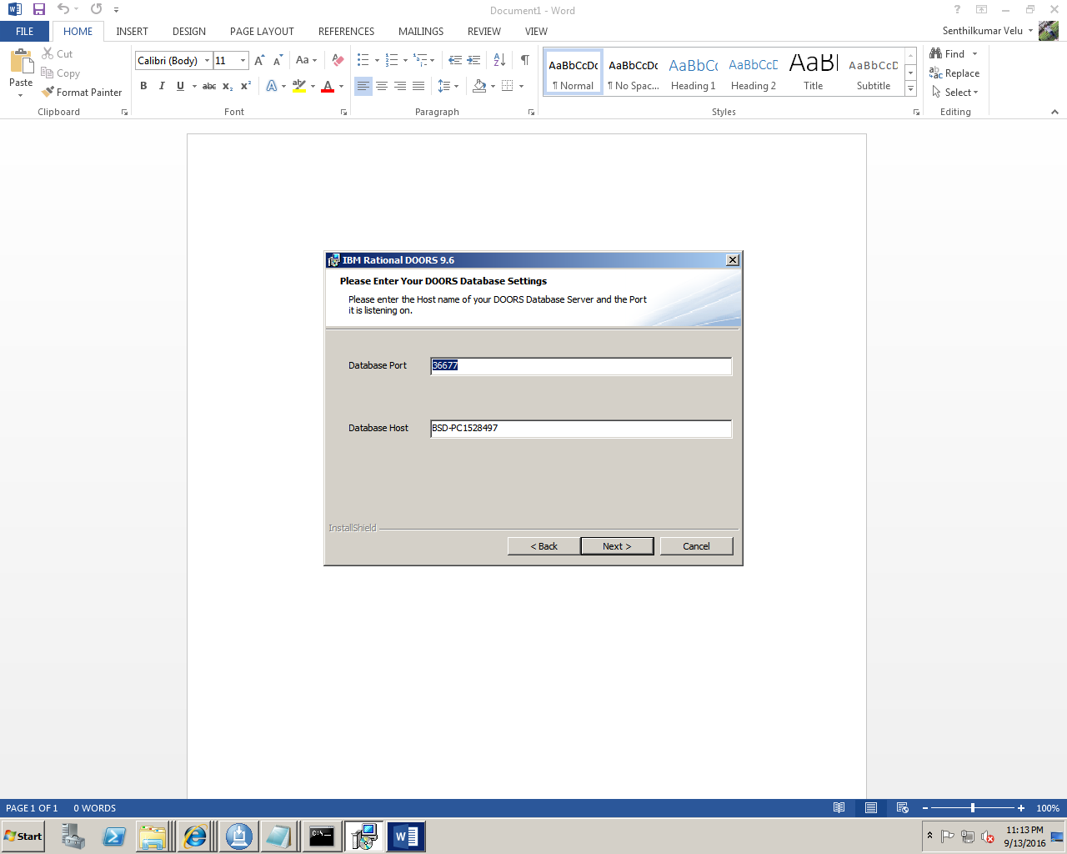

The following repositories are not connected:

-https://jazz.net/downloads/clm/5.0.2/5.0.2/install-repository/clm-offerings/repository/repository.config

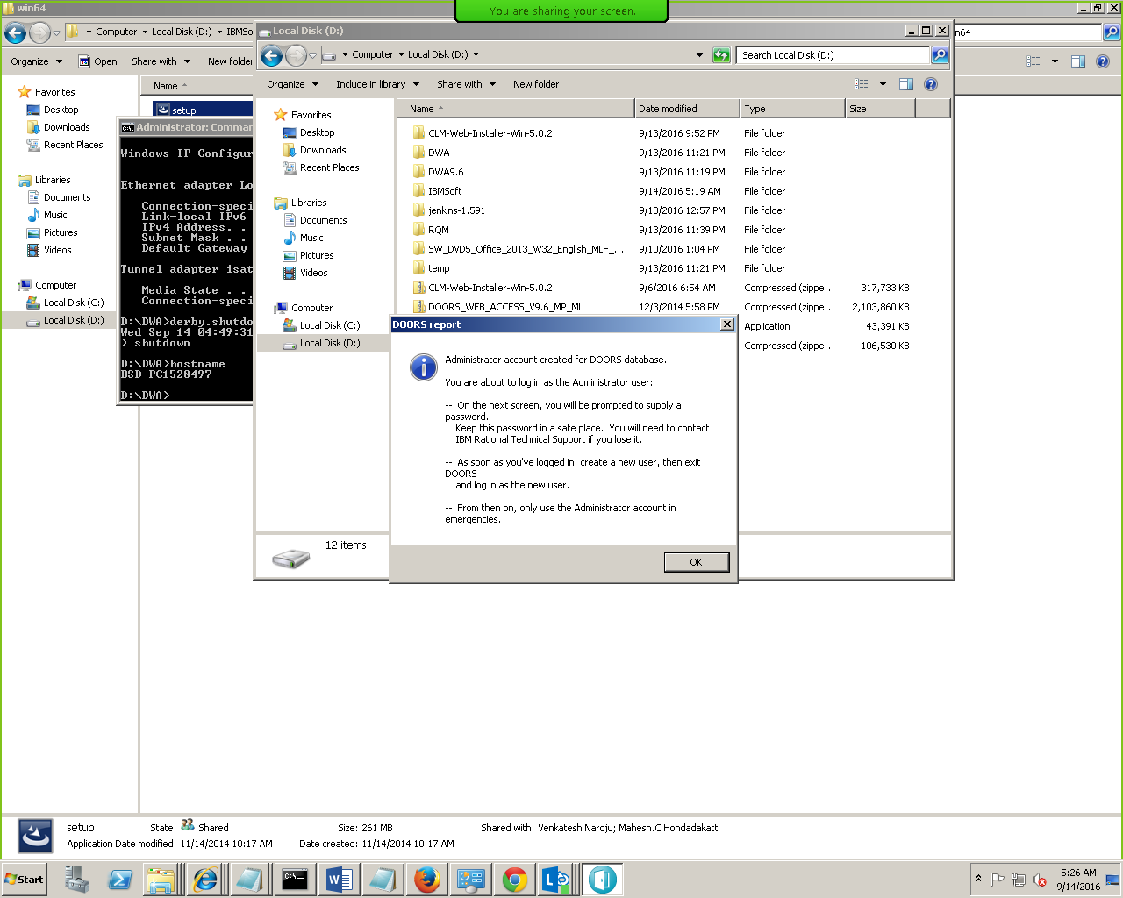

Doors Admin login uid pwd

Administrator/clmadmin

port 36677 this db port

DOORS URL

doors://BSD-PC1528497:36677/?version=2&prodID=0&urn=urn:telelogic::1-57d941b0109f1eff-A

FQDN of the sytem

BSD-PC1528497.TechMahindra.com

dbadmin -dcnEnable -data 36677@BSD-PC1528497 -dcnBrokerUri “tcp://BSD-PC1528497.TechMahindra.com:61616“ -dcnChannelName “dcn“ -dwaHost BSD-PC1528497.TechMahindra.com -dwaPort 8443 -dwaProtocol https

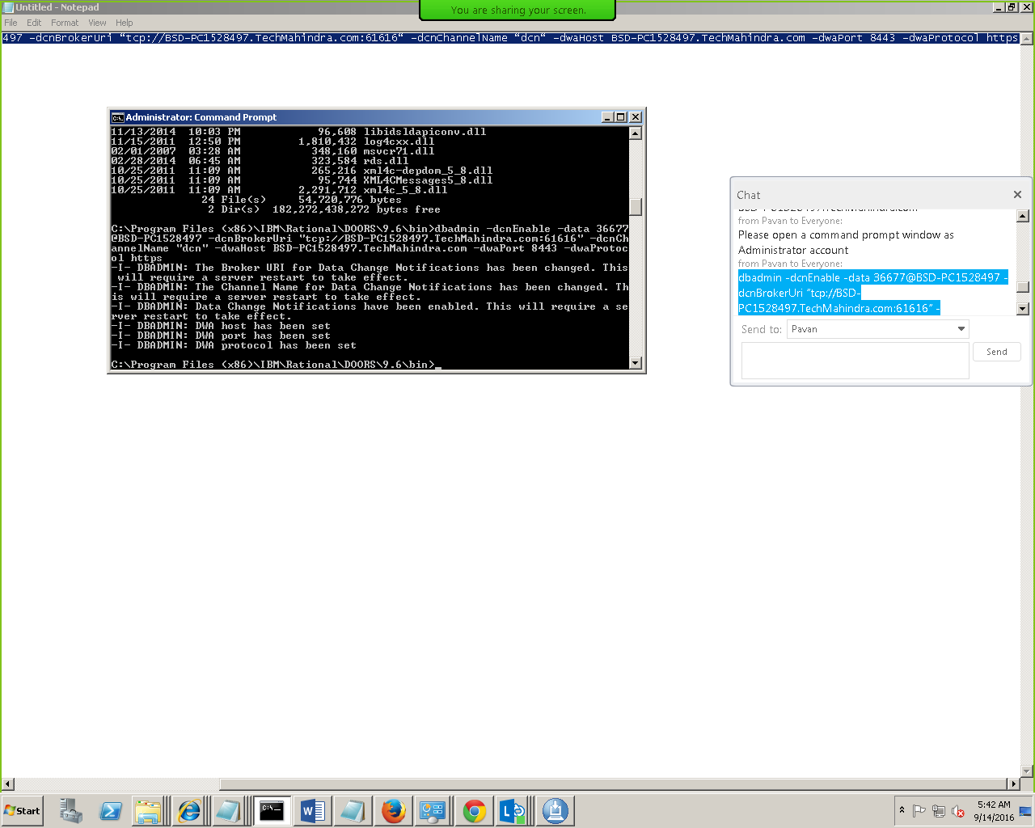

<https://bsd-pc1528497.techmahindra.com:8443/dwa/rm/urn:rational::1-57d941b0109f1eff-A>

DOORs DWA URL

<https://bsd-pc1528497.techmahindra.com:8443/dwa/rm/urn:rational::1-57d941b0109f1eff-M-00000020>

Jenkins URL - <http://bsd-pc1528497:8080/login?from=%2F>

Admin/admin

ID

57d941b0109f1eff

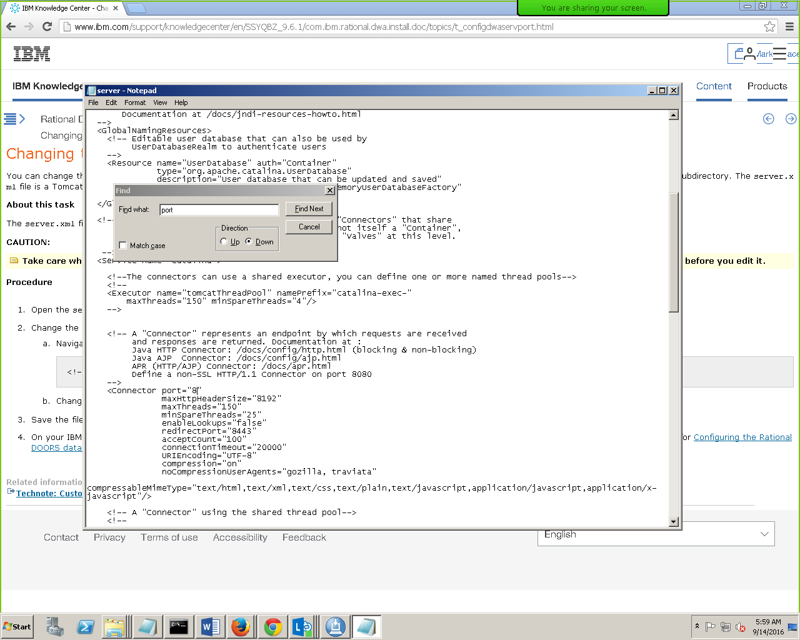

Port changes to 8083

To start DWA follow below sequence

D:\dwa

Broker.start.bat

Derby.start.bat

Start introp short cut icon created at desktop

Server.start.bat

DWA URL login page

<https://bsd-pc1528497.techmahindra.com:8443/dwa>

Administrator/clmadmin

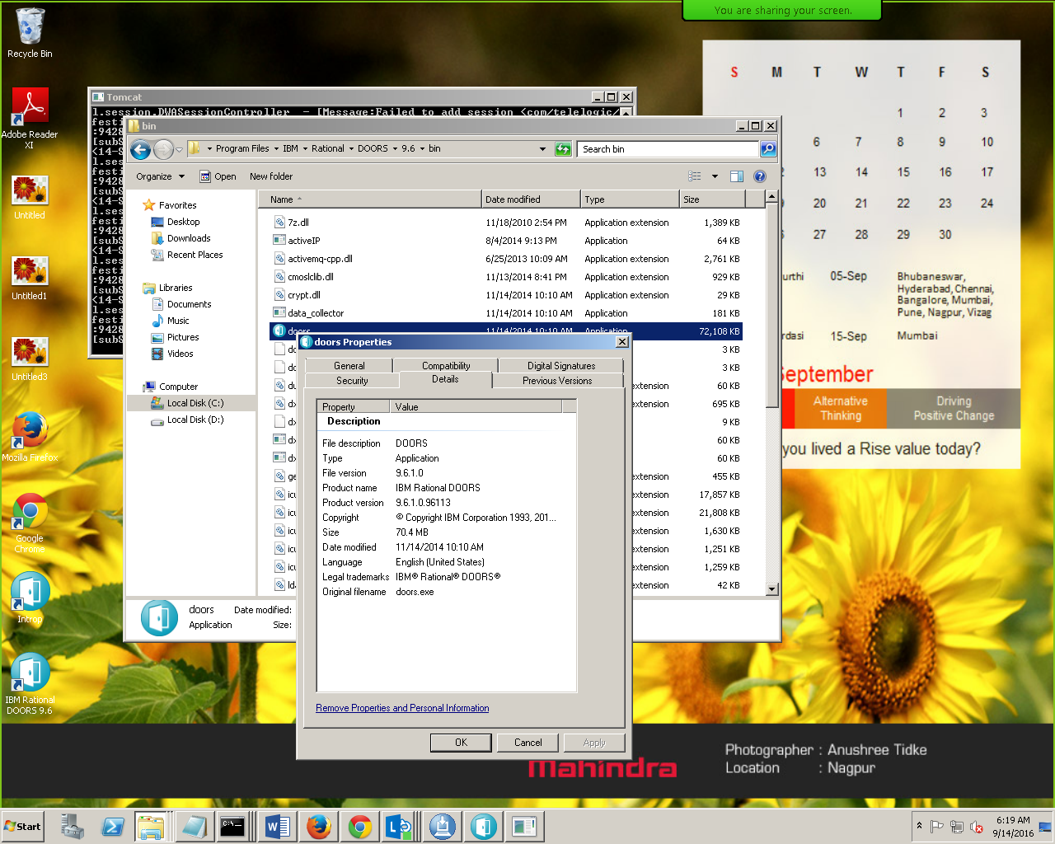

Doors 9.6.1 download url

<http://www-01.ibm.com/support/docview.wss?uid=swg24038346#DNLD>

DWA 9.6.1 Installation

D:\DWA961\DWA9.6.1\Installer\win64

IBM_Rational_DOORS_Web_Access.exe

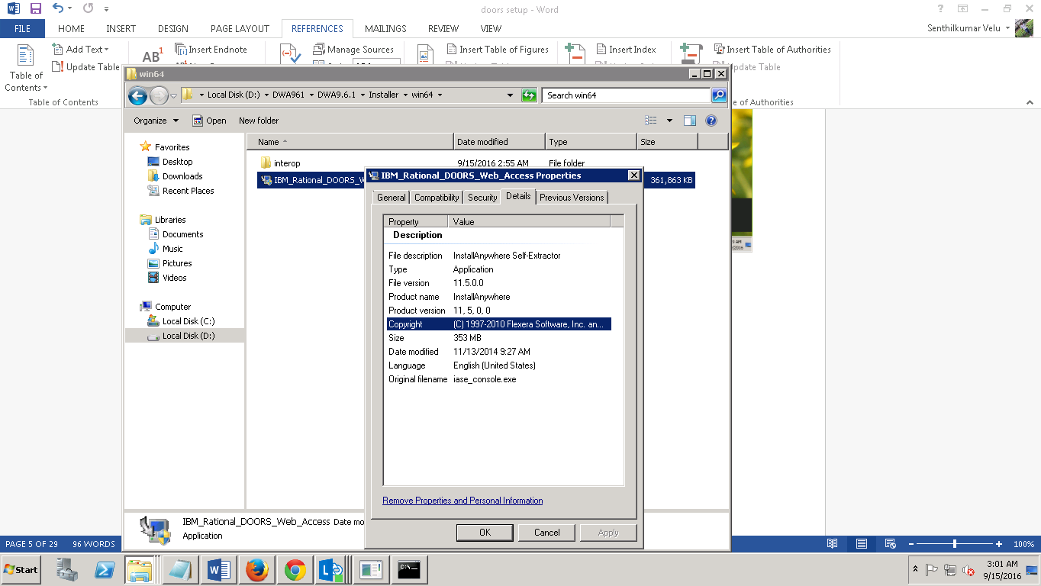

Execute it from command prompt and run CMD as Administrator

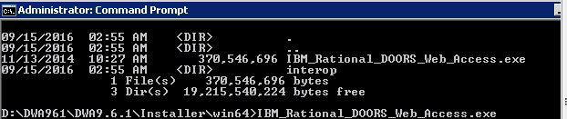

RQM Installation

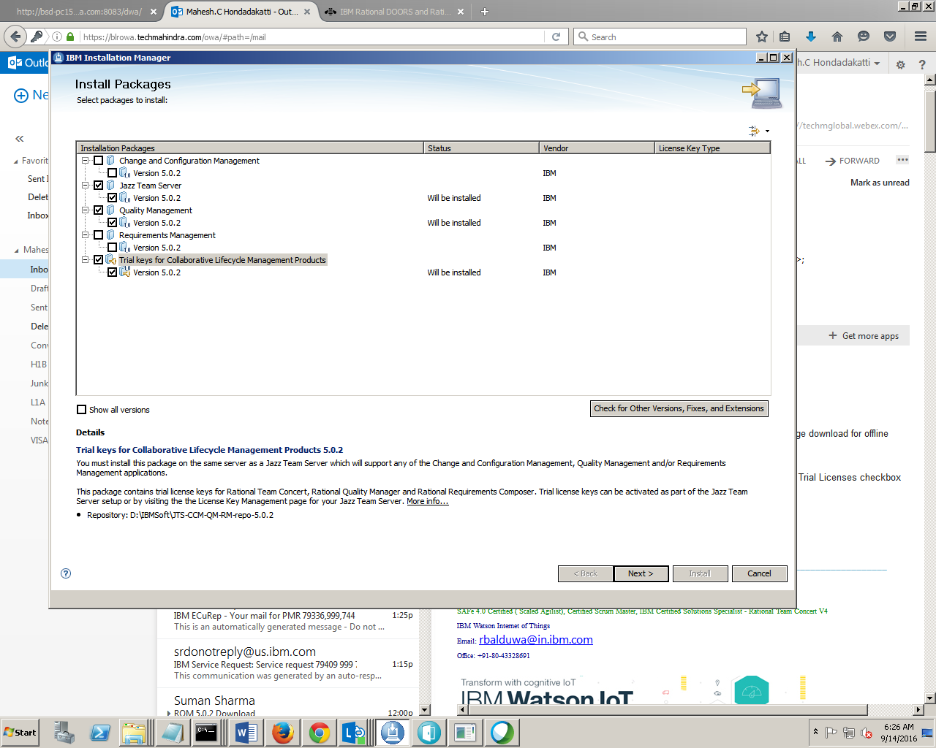

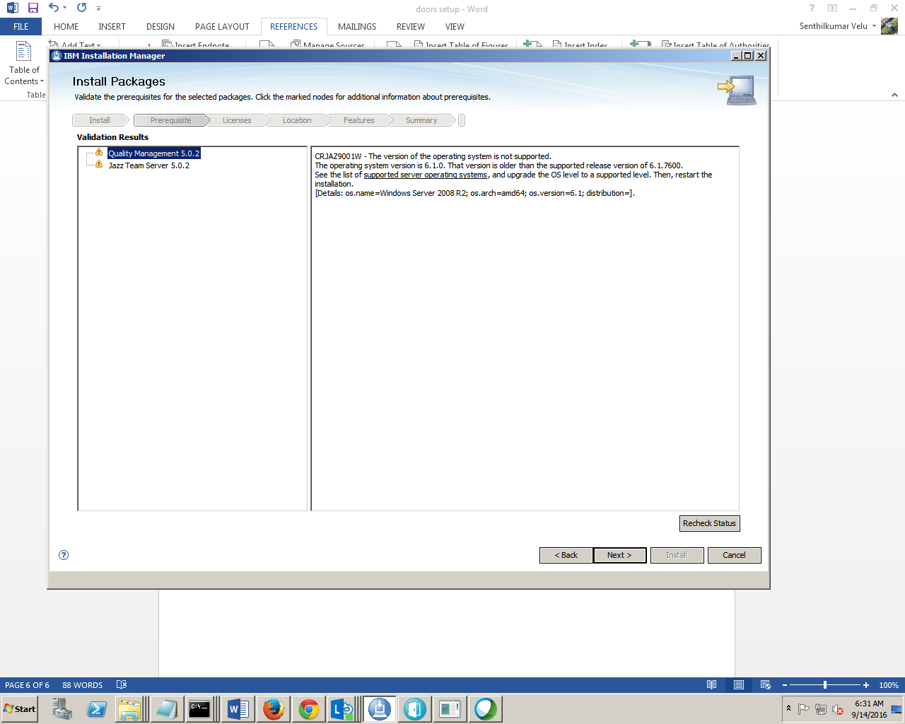 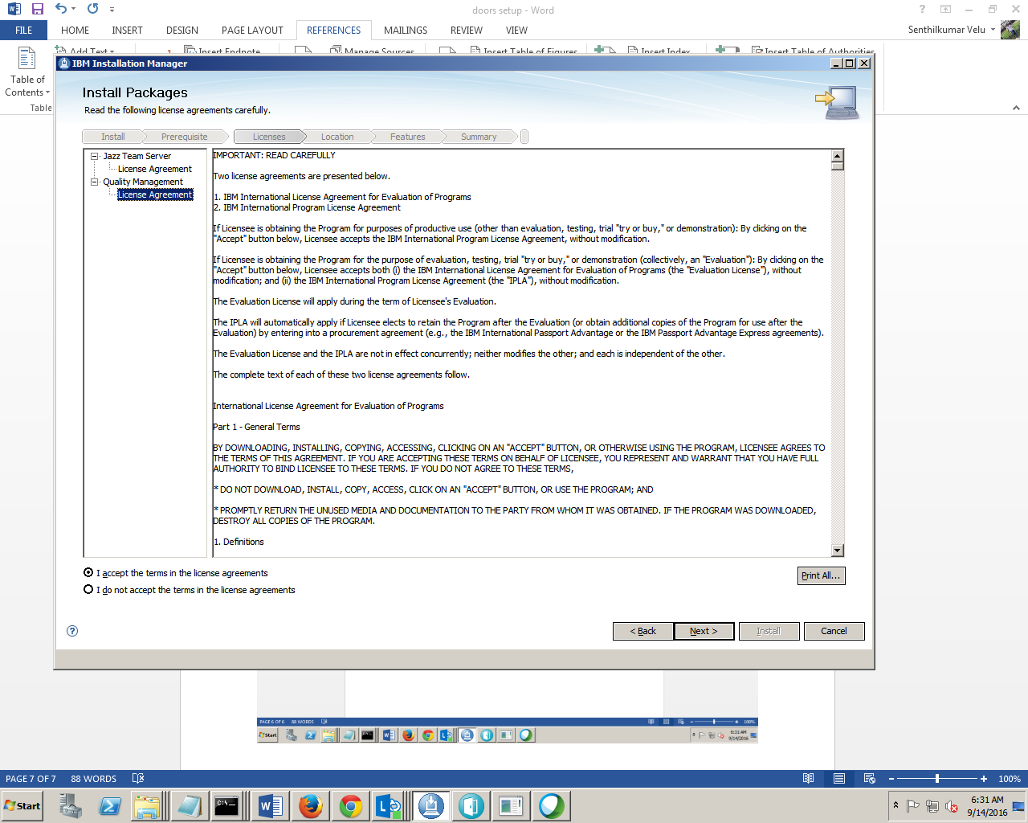 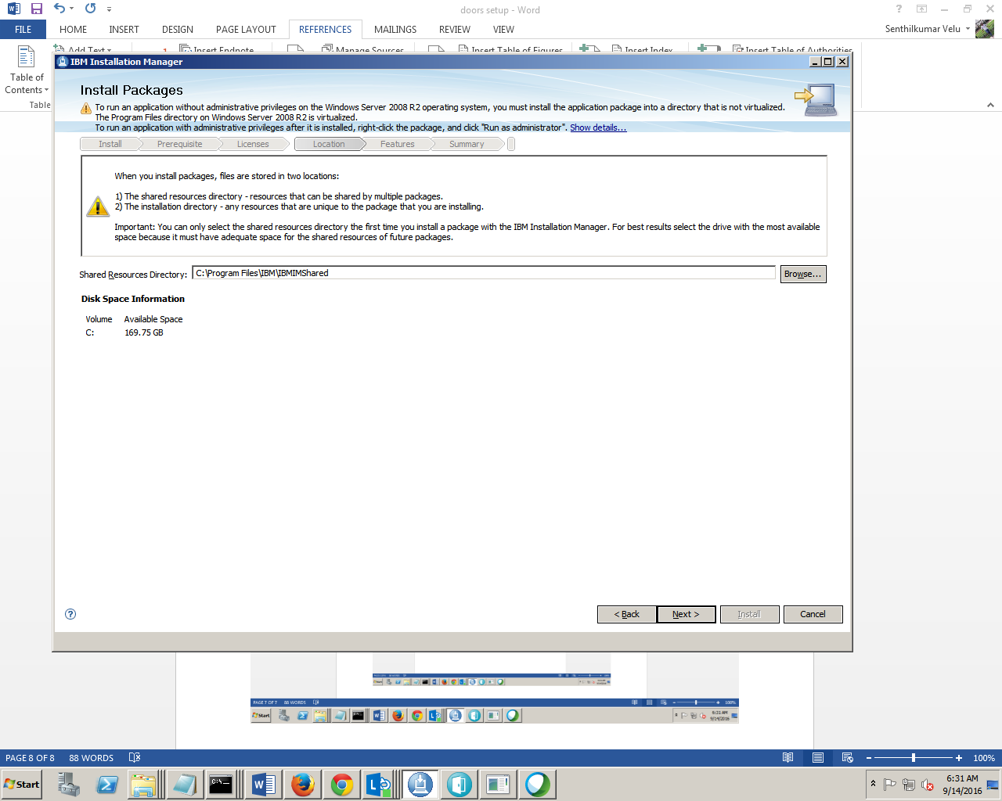 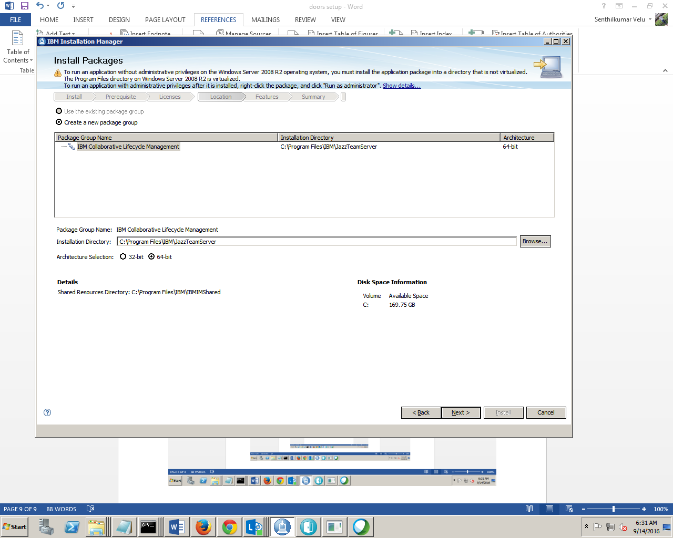 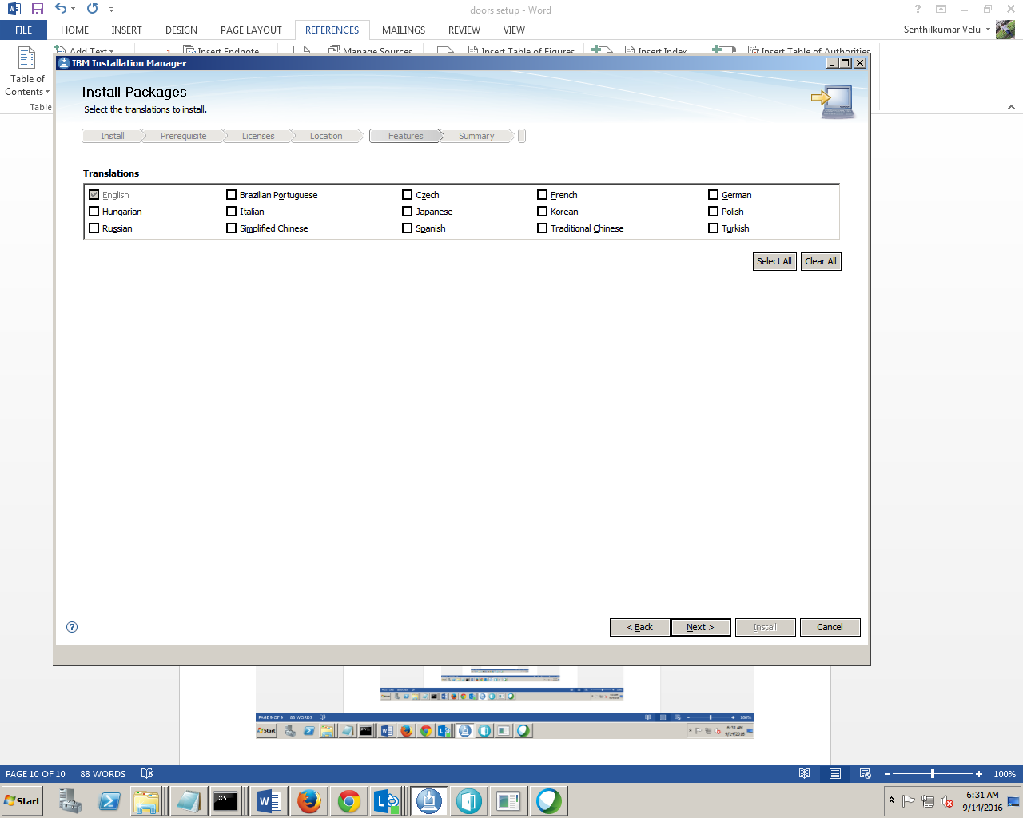 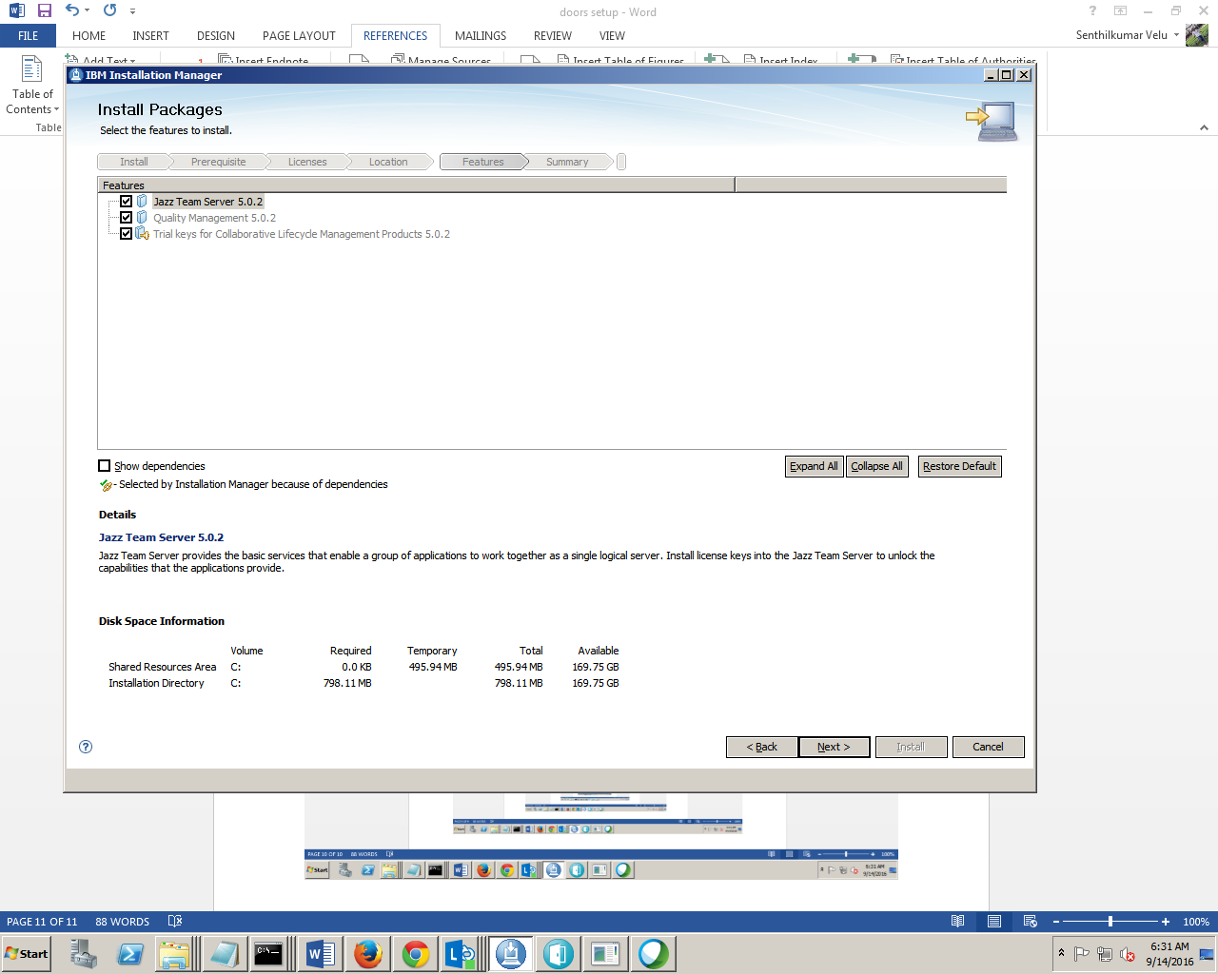 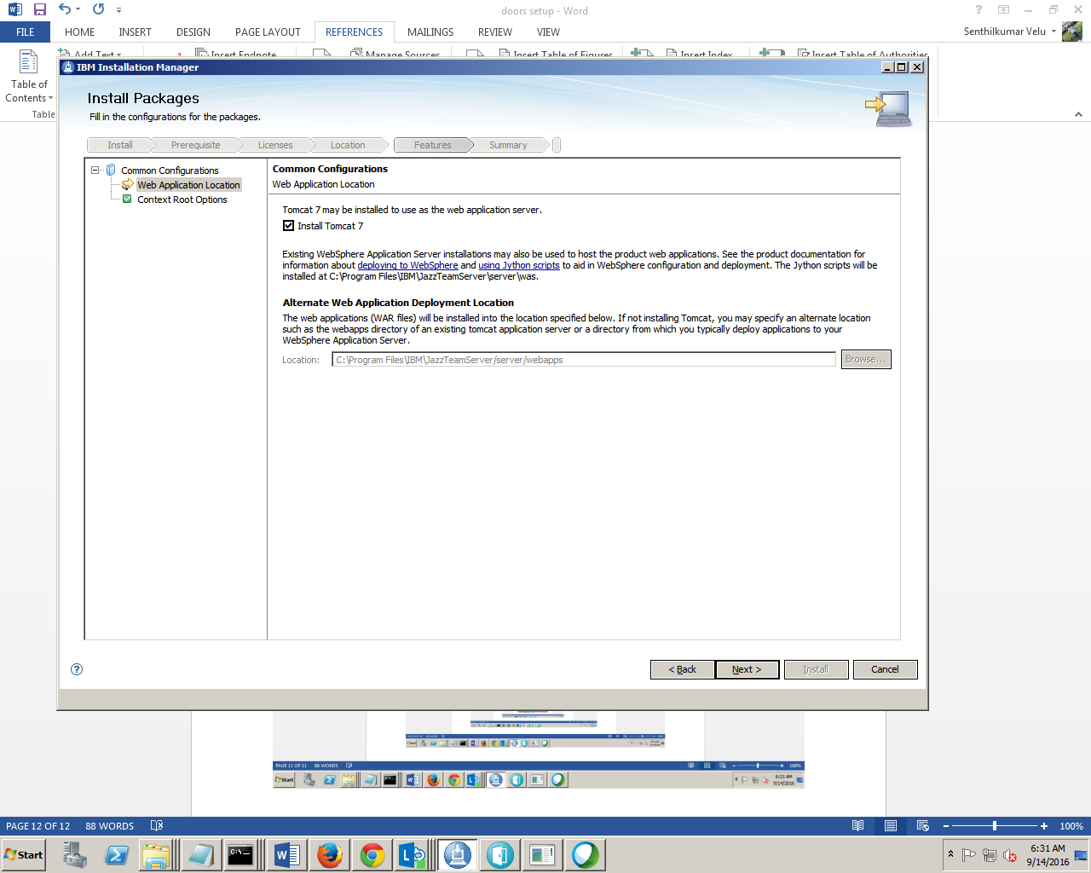 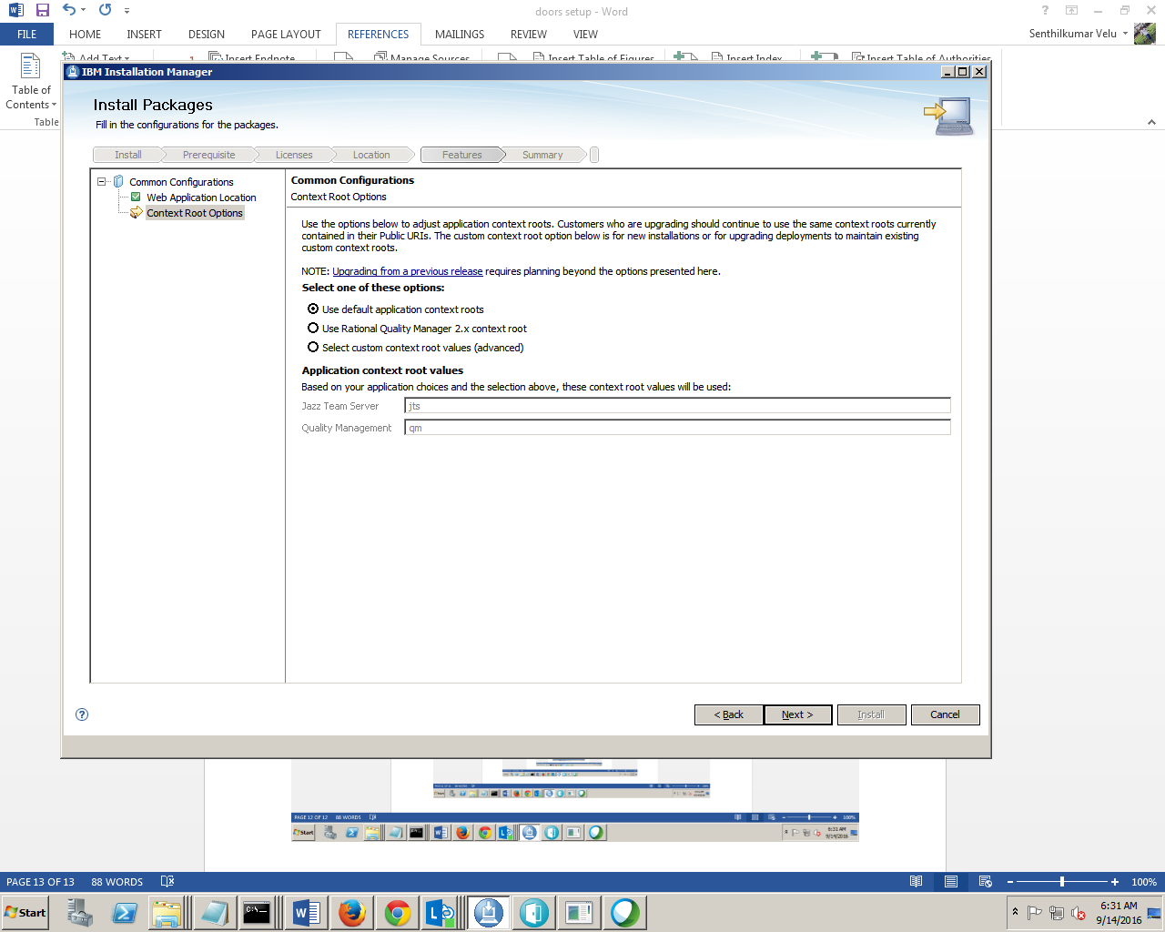 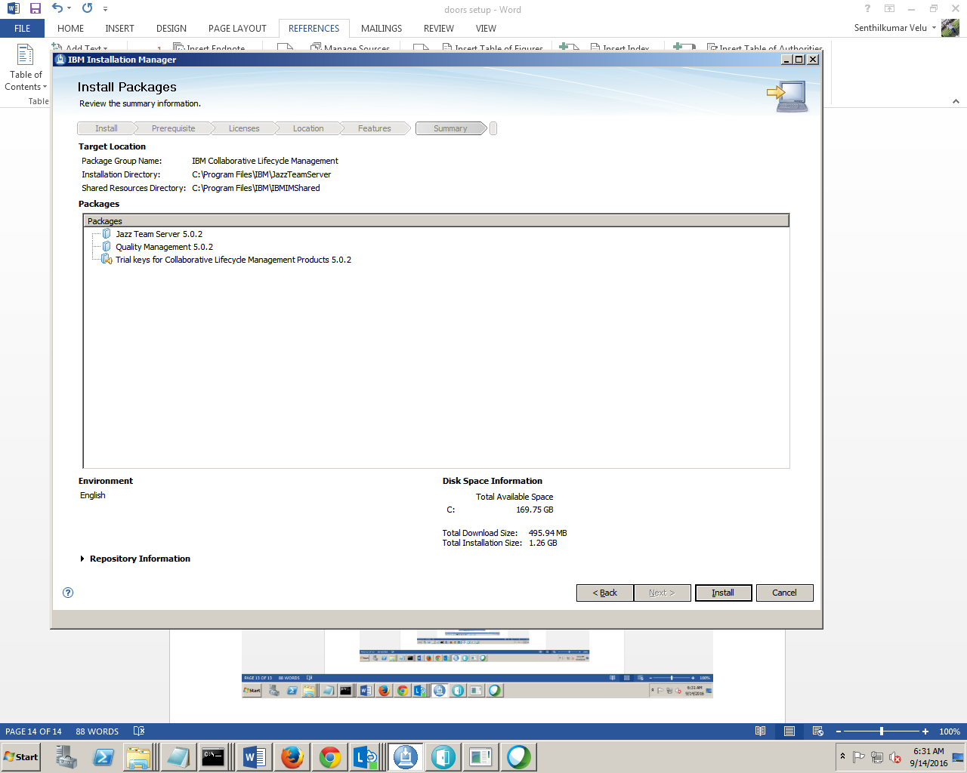

<https://bsd-pc1528497:9443/jts/admi>

clmadmin/clmadmin

ADMIN/ADMIN

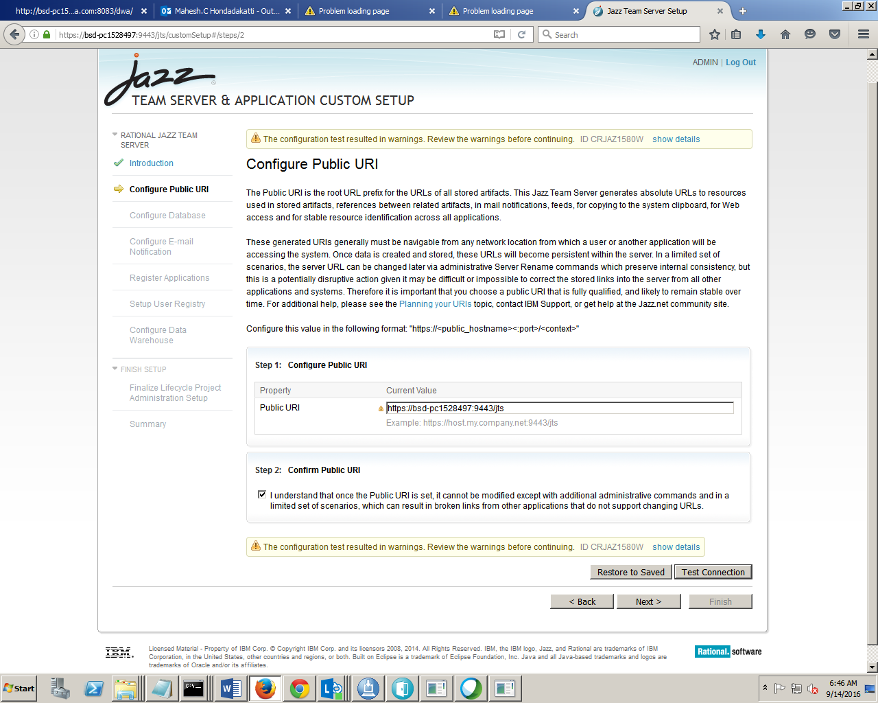 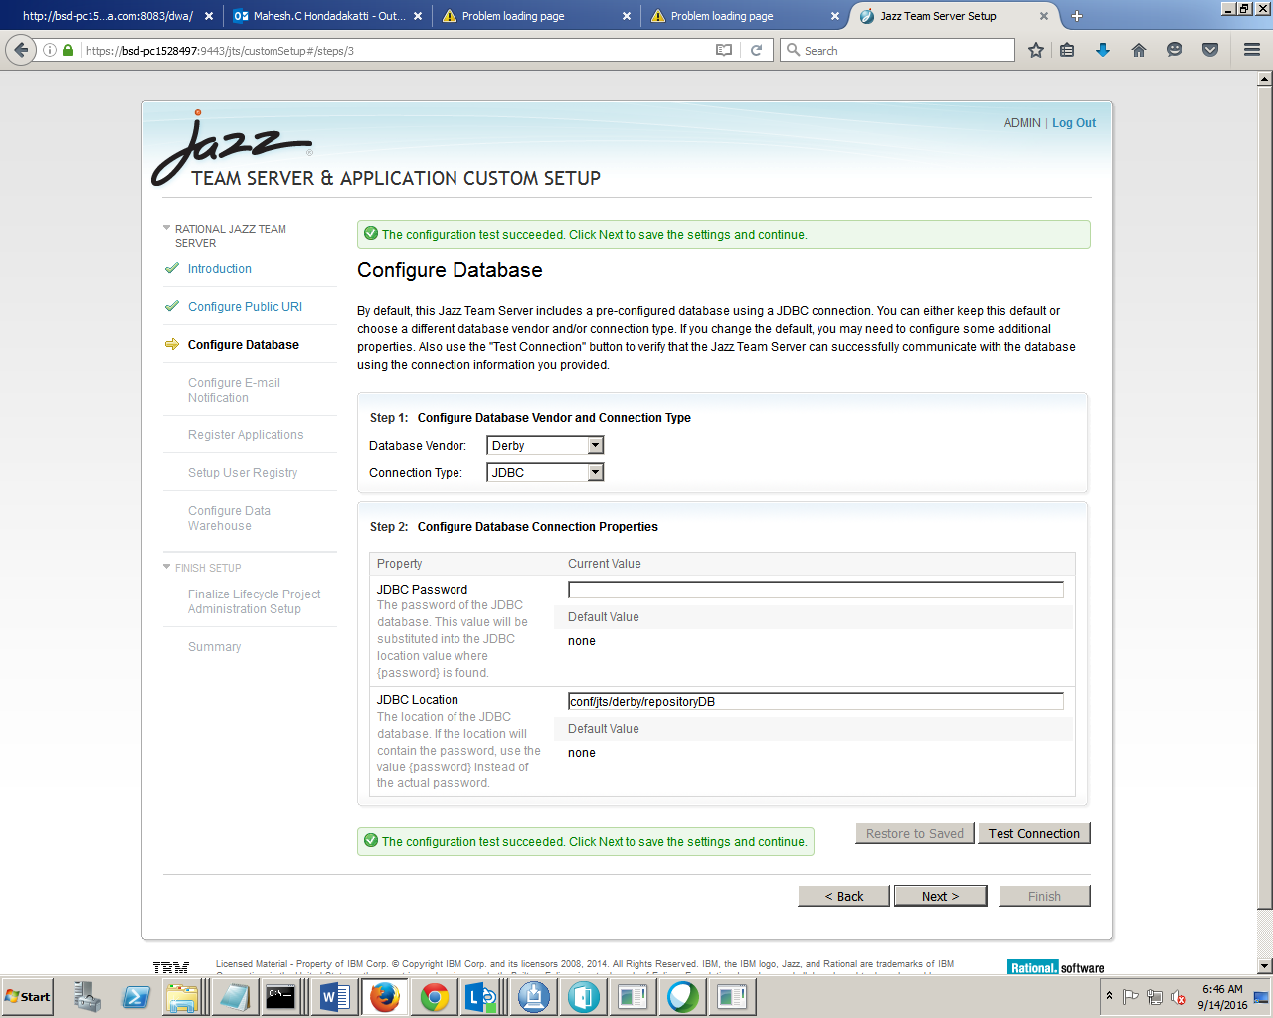 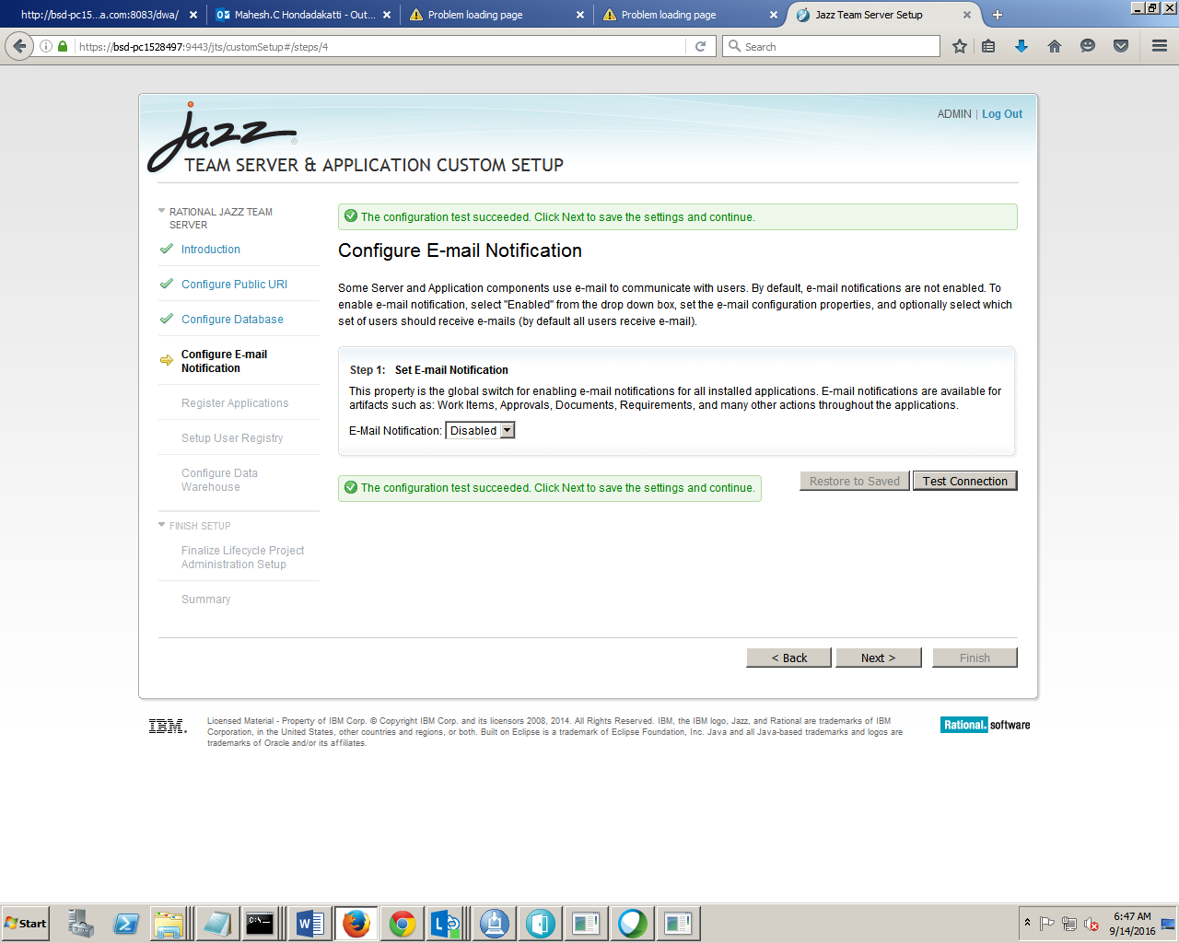 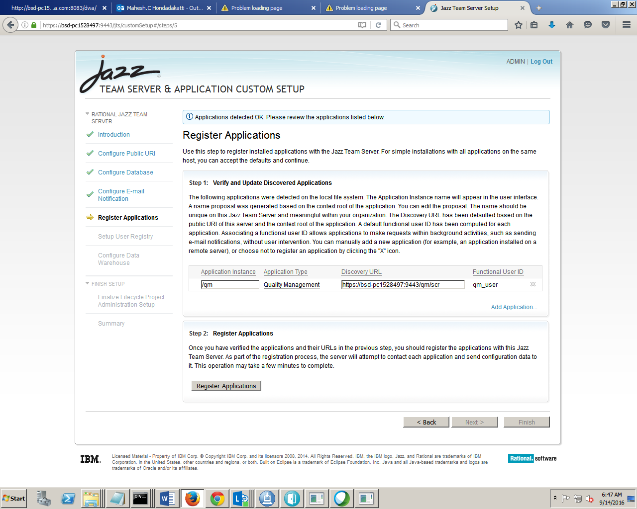 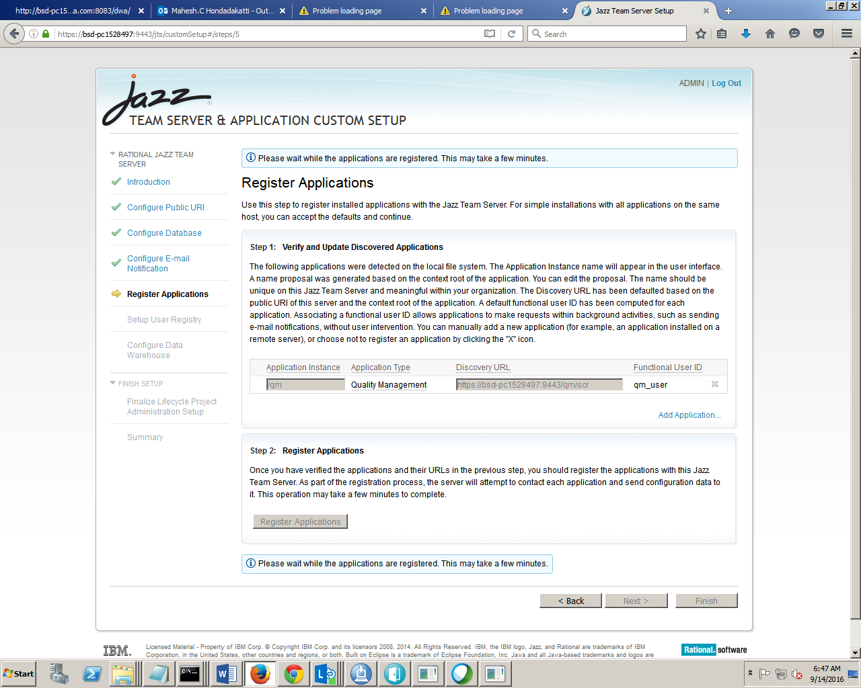 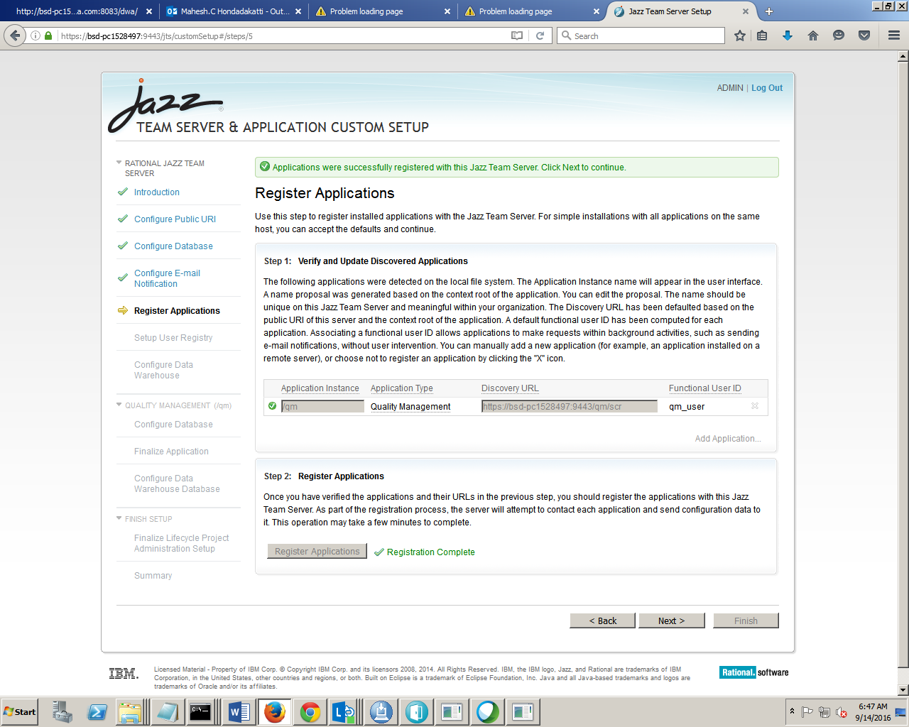 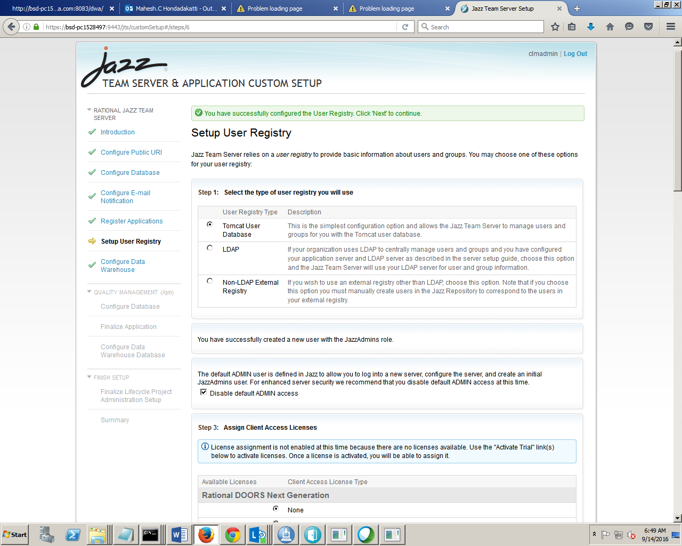 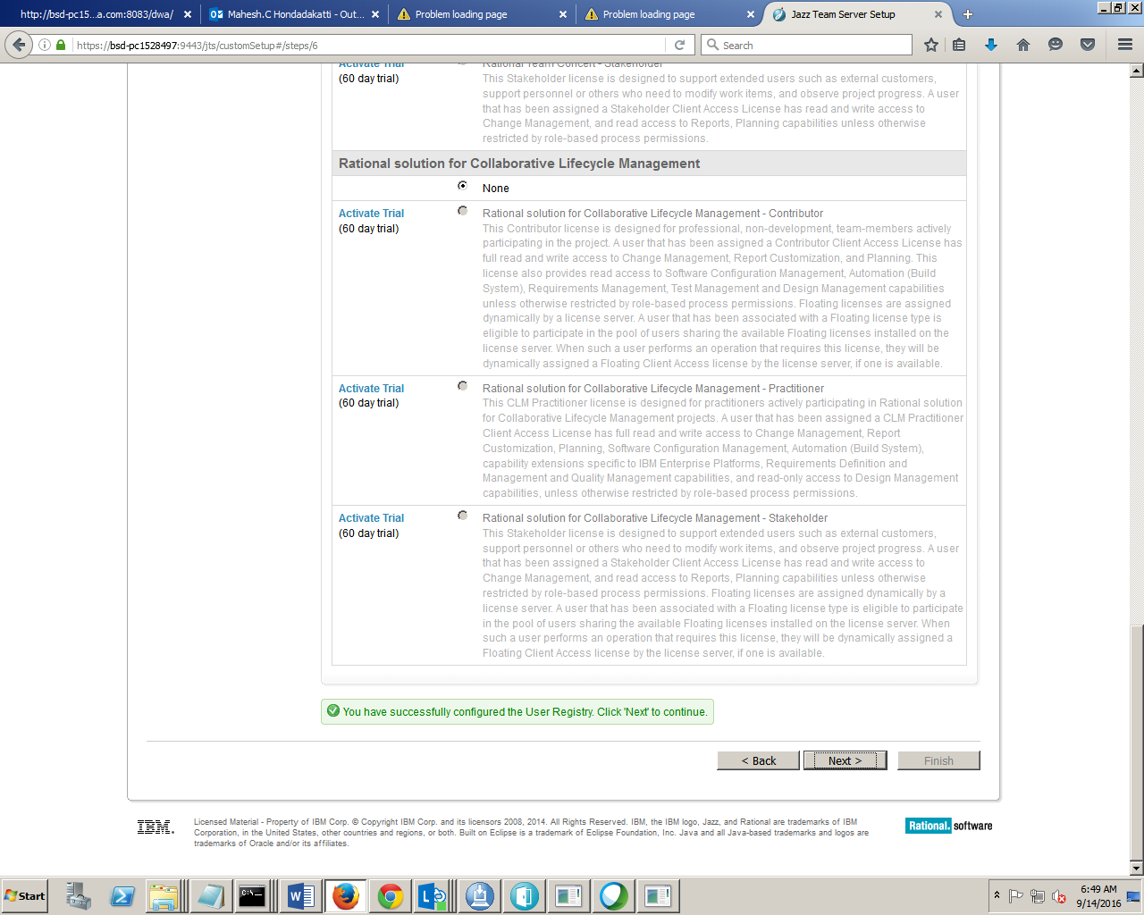 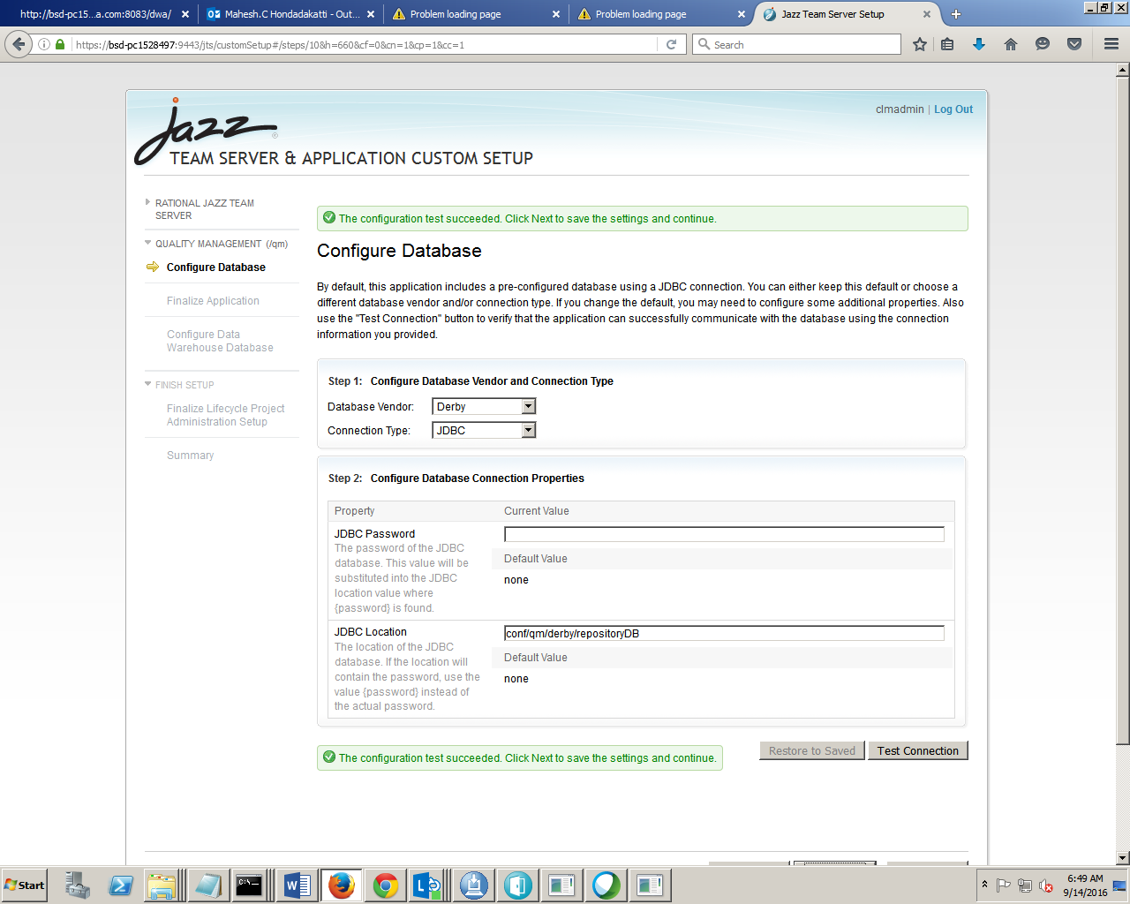 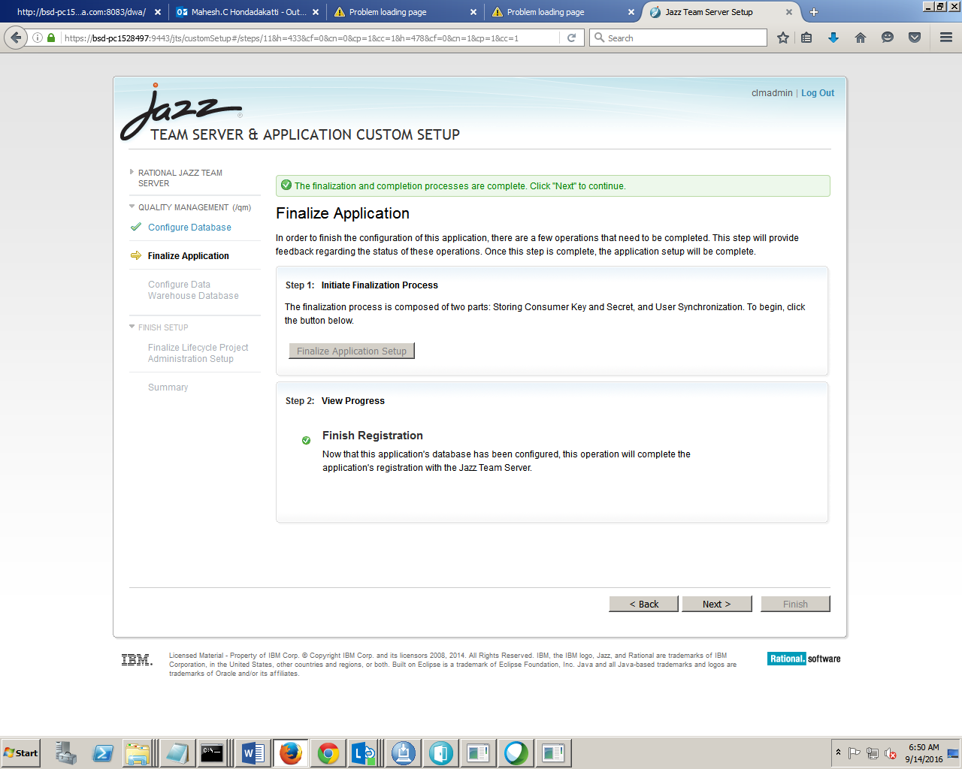 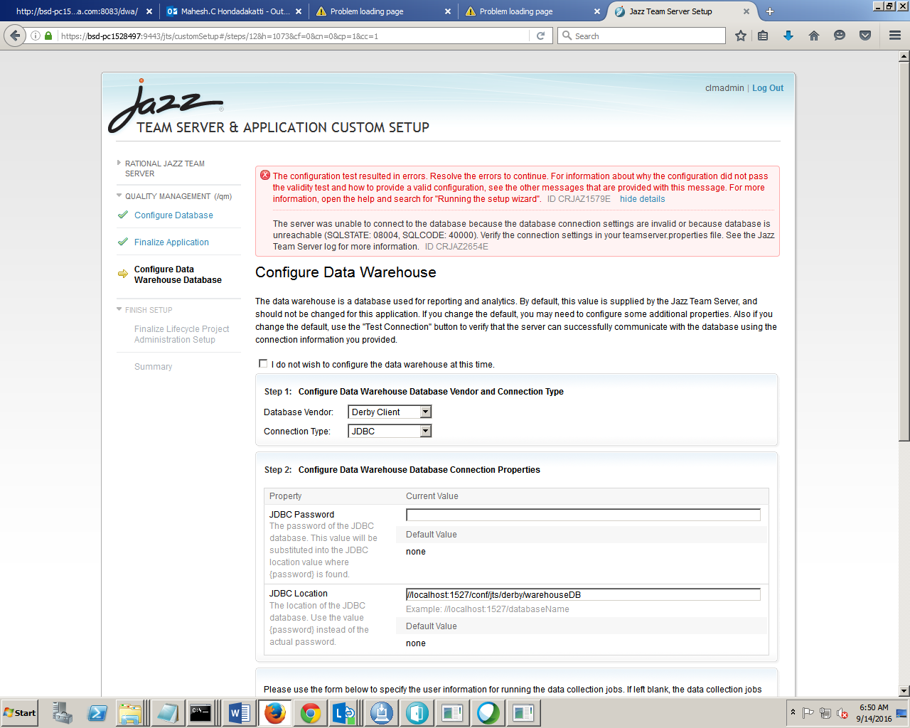 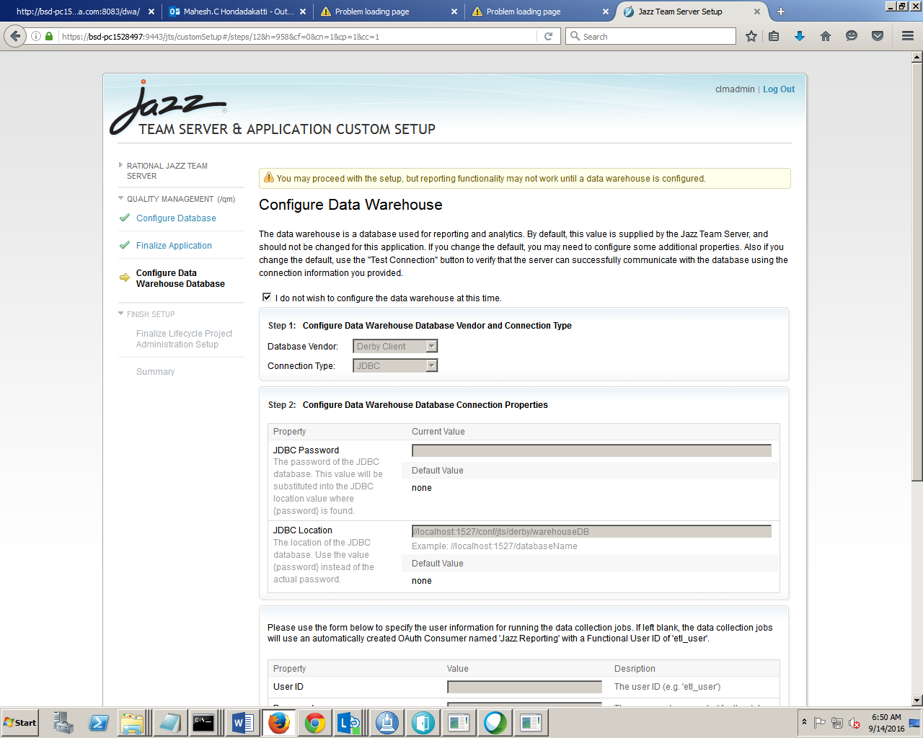 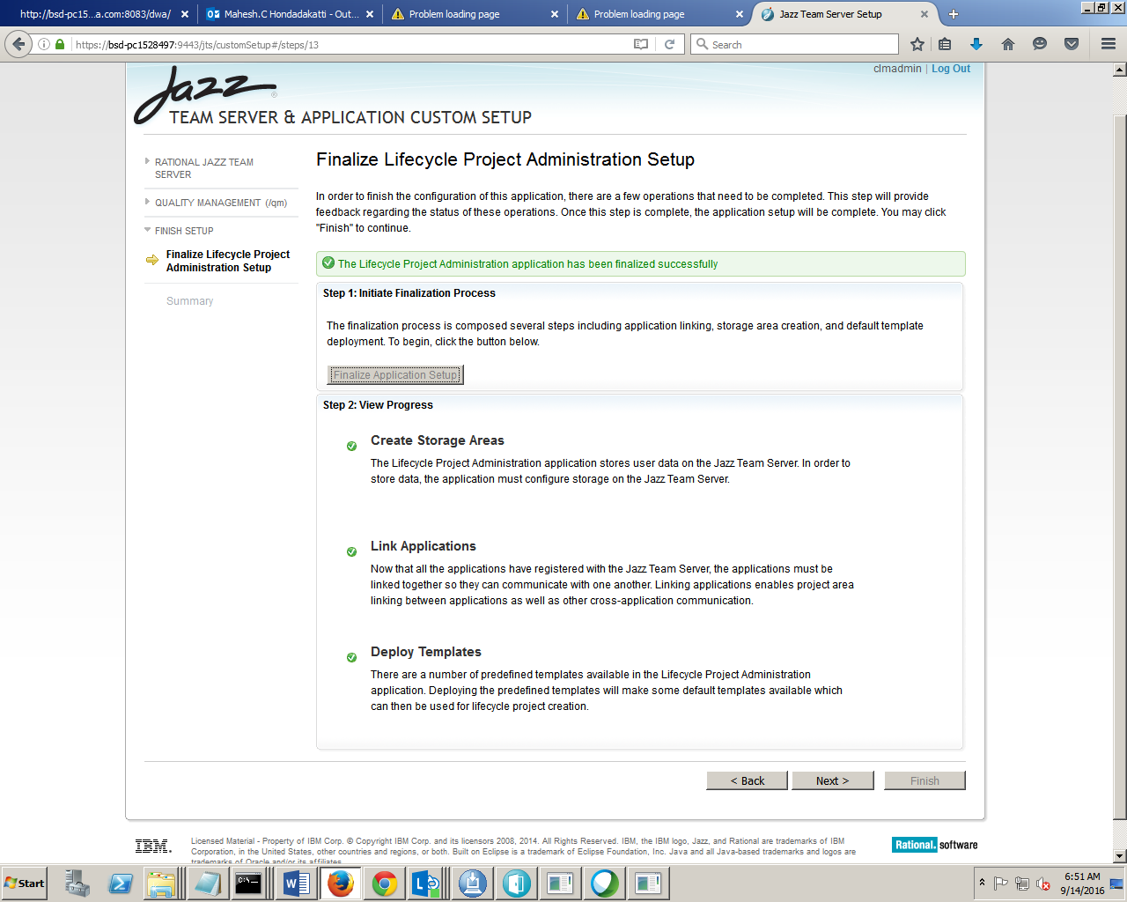 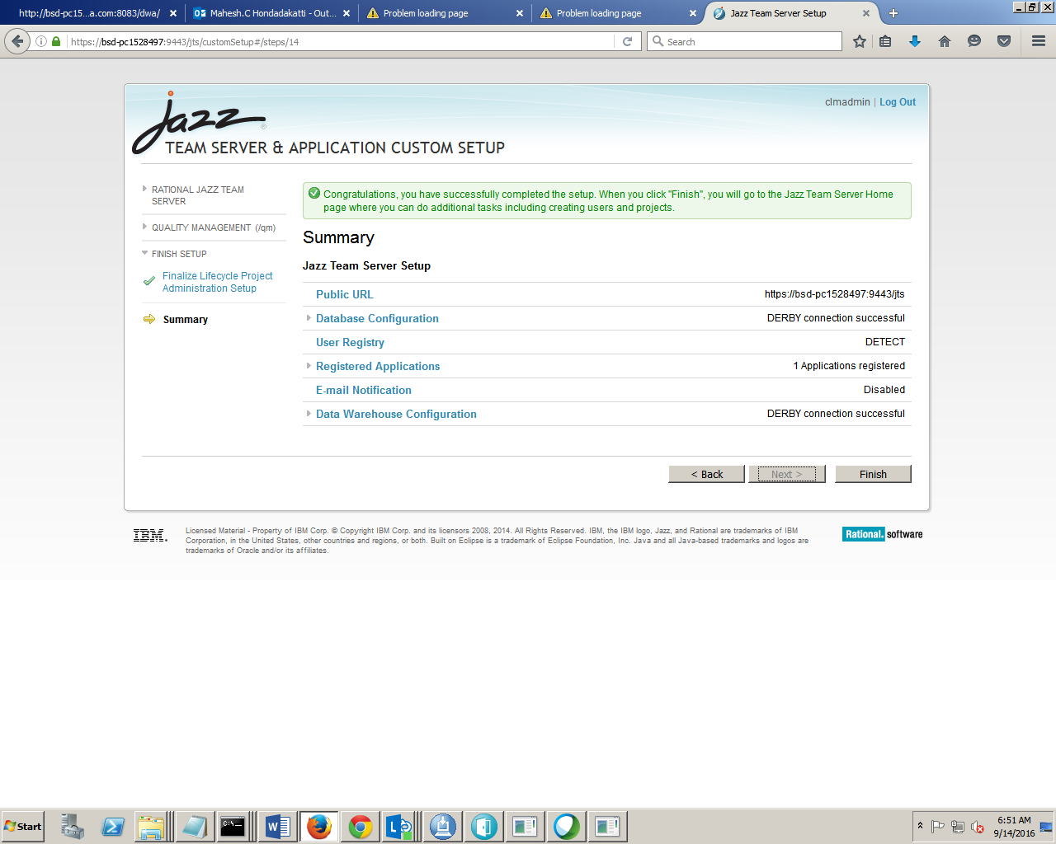

How to trigger Jenkins job from command line use below command also enable Random in Jnekins under Global Security

java -jar jenkins-cli.jar -s http://bsd-pc1528497:8080/job/Test-Job/ build Test-Job --username admin --password admin

